**USMAN MARUF**

**3041120**

**COMPUTER ENGINEERING 4**

4.a.

The maximum frequency humans can hear is 20 kHz. In musical applications however, it may be lower. For practical purposes, we assume the maximum frequency to be 20 kHz. Then by Nyquist rate will be 40 kHz.

The sampling period is therefore 1/40 kHz ≈ 2.5 ×10−5 seconds.

4.b.

load bach_fugue.mat

note_durations = theVoices.durations;

note_numbers = theVoices.noteNumbers;

note_frequencies = 440 * 2.^((note_numbers - 69)/12);

total_duration = sum(note_durations);

4.c.

load bach_fugue.mat

note_durations = theVoices.durations;

note_numbers = theVoices.noteNumbers;

note_frequencies = 440 * 2.^((note_numbers - 69)/12);

total_duration = sum(note_durations);

fs = 40000;

total_samples = round(total_duration * fs);

waveform = zeros(1, total_samples);

current_sample = 1;

for i = 1:length(note_numbers)

duration = note_durations(i);

num_samples = round(duration * fs);

t = (0:num_samples-1) / fs; % Time vector for the current note

f = note_frequencies(i); % Frequency of the current note

sinusoid = sin(2 * pi * f * t);

waveform(current_sample:current_sample+num_samples-1) = sinusoid;

current_sample = current_sample + num_samples;

end

4.d.

selected_notes = [1, 2, 3];

figure;

hold on;

for i = selected_notes

duration = note_durations(i);

num_samples = round(2 * (1/f) * fs);

t = (0:num_samples-1) / fs; % Time vector for the current note

f = note_frequencies(i); % Frequency of the current note

sinusoid = sin(2 * pi * f * t);

plot(t, sinusoid, 'DisplayName', sprintf('Note %d: %.2f Hz', note_numbers(i), f));

end

xlabel('Time (seconds)');

ylabel('Amplitude');

title('Waveforms of Selected Notes');

legend;

hold off;

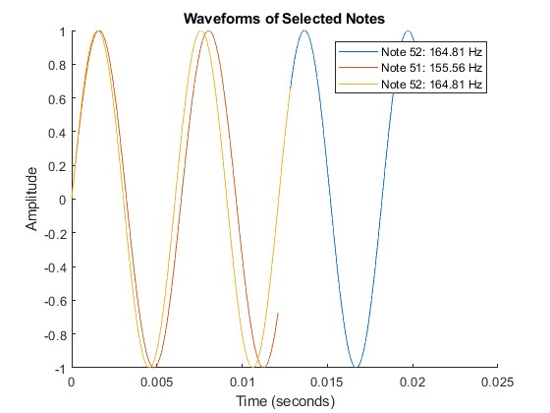

4.e.

load bach_fugue.mat

note_durations = theVoices.durations;

note_numbers = theVoices.noteNumbers;

note_frequencies = 440 * 2.^((note_numbers - 69)/12);

total_duration = sum(note_durations);

fs = 40000;

total_samples = round(total_duration * fs);

waveform = zeros(1, total_samples);

current_sample = 1;

figure;

hold on;

for i = 1:length(note_numbers)

duration = note_durations(i);

num_samples = round(duration * fs);

t = (0:num_samples-1) / fs; % Time vector for the current note

f = note_frequencies(i); % Frequency of the current note

sinusoid = sin(2 * pi * f * t);

waveform(current_sample:current_sample+num_samples-1) = sinusoid;

current_sample = current_sample + num_samples; % Update the current sample index

end

portion_duration = 2; % seconds

portion_samples = round(portion_duration * fs);

portion_waveform = waveform(1:portion_samples);

window_length = 512;

overlap = window_length / 2;

nfft = 1024;

figure;

spectrogram(portion_waveform, window_length, overlap, nfft, fs, 'yaxis');

title('Spectrogram of a Portion of the Synthesized Music');

ylim([0 2]);

colorbar;

